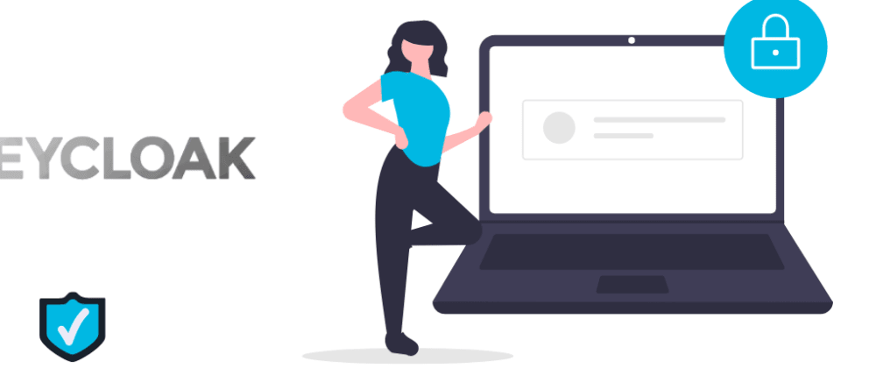

# How to install keycloak in local machine

# Pre-requisites:

# Java

# Keyclock

# Postgres or any supported database

# Database driver jar file

# Certificates

### **Download and install JDK**

If java is not installed,

* Install Java SDK 17+
* Add the path to environmental variables

Official documentation is right [here](https://www.keycloak.org/documentation.html)

### **Download and install keycloak**

* Download the latest version of keycloak from [here](https://www.keycloak.org/downloads.html) .
* Take the zip file and unzip
* At the time of writing this I am using keycloak 22.0.1

***My computer keycloak location is D:\Apps\keycloak***

### **Download JDBC Driver JAR file**

Download from the below URL

[**https://jdbc.postgresql.org/download/**](https://jdbc.postgresql.org/download/)

**Download the JDBC Driver JAR file and place it into Keyclock’s providers folder**

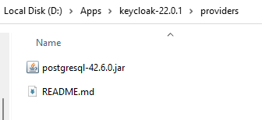

### **Generate certificate locally**

Download the Certificate generation tool from the URL below

<https://github.com/FiloSottile/mkcert>

mkcert is a simple tool for making locally-trusted development certificates. It requires no configuration.

* mkcert keyclock.com.in

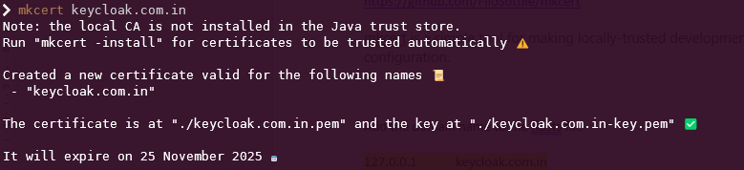

### **Add the domain name to the hosts file**

127.0.0.1 keycloak.com.in

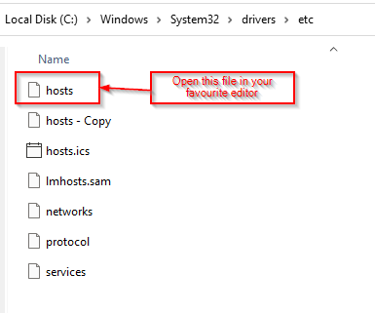

### **Execute below statements on database**

DROP DATABASE keyclock;

CREATE DATABASE keyclock WITH ENCODING 'UTF8';

CREATE ROLE keyclock WITH LOGIN SUPERUSER PASSWORD 'password123';

GRANT ALL PRIVILEGES ON DATABASE keyclock TO keyclock;

### **Edit the keyclock.conf file as per your database, hostname, certificate**

[HTTPS for localhost. There are cases where we need to have a… | by Suman Kunwar | Medium](https://sumn2u.medium.com/https-for-localhost-4853b417925b)

<https://sumn2u.medium.com/https-for-localhost-4853b417925b>

db=postgres

db-username=keyclock

db-password=password 123

db-url=jdbc:postgresql://localhost:5432/keyclock

https-certificate-file=**D:/Apps/keycloak-22.0.1/conf/keycloak.com.in.pem**

https-certificate-key-file=**D:/Apps/keycloak-22.0.1/conf/keycloak.com.in-key.pem**

hostname=keyclock.com.in

hostname-strict=false

http-enabled=true

***Note: Full path of the Certificate needs to be provided, otherwise it will not work!!***

### **Execute the command from the location where keyclock is installed**

### **(In my case D:/Apps/keyclock_22.0.1/bin)**

***D:/Apps/keyclock_22.0.1/bin> .\kc.bat build --db postgres***

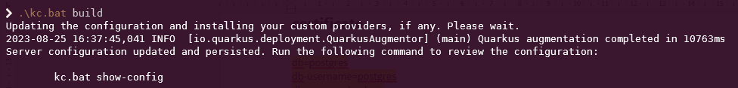

***D:/Apps/keyclock_22.0.1/bin> .\kc.bat start***

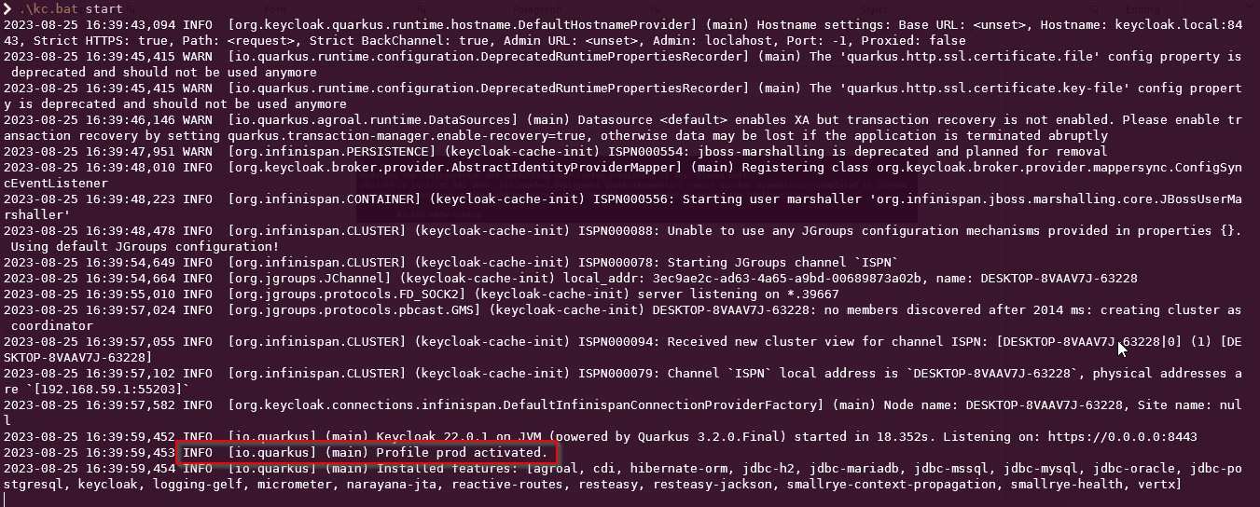

Open your favourite browser <https://localhost:8443/>

***Note : If possible restart your keyclock, once you created the initial admin user and password***

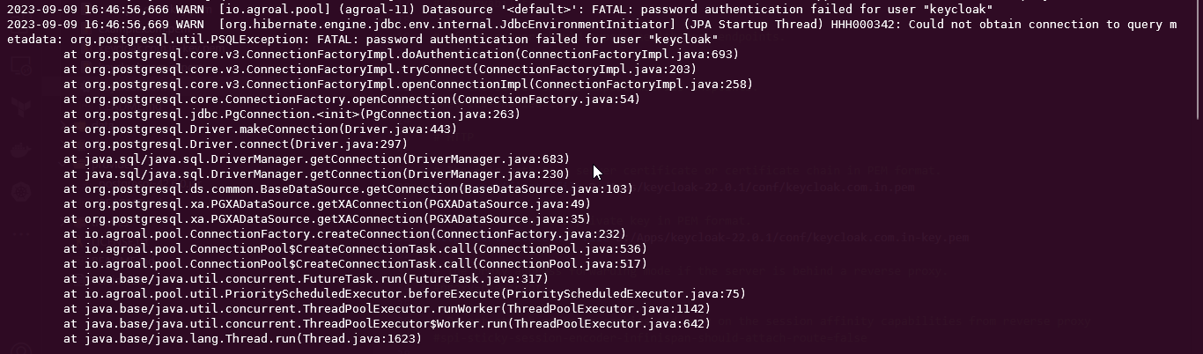

***Check the spelling/username/password***

***Note : In my case database and user was keyclock, and I configured it as keycloak***

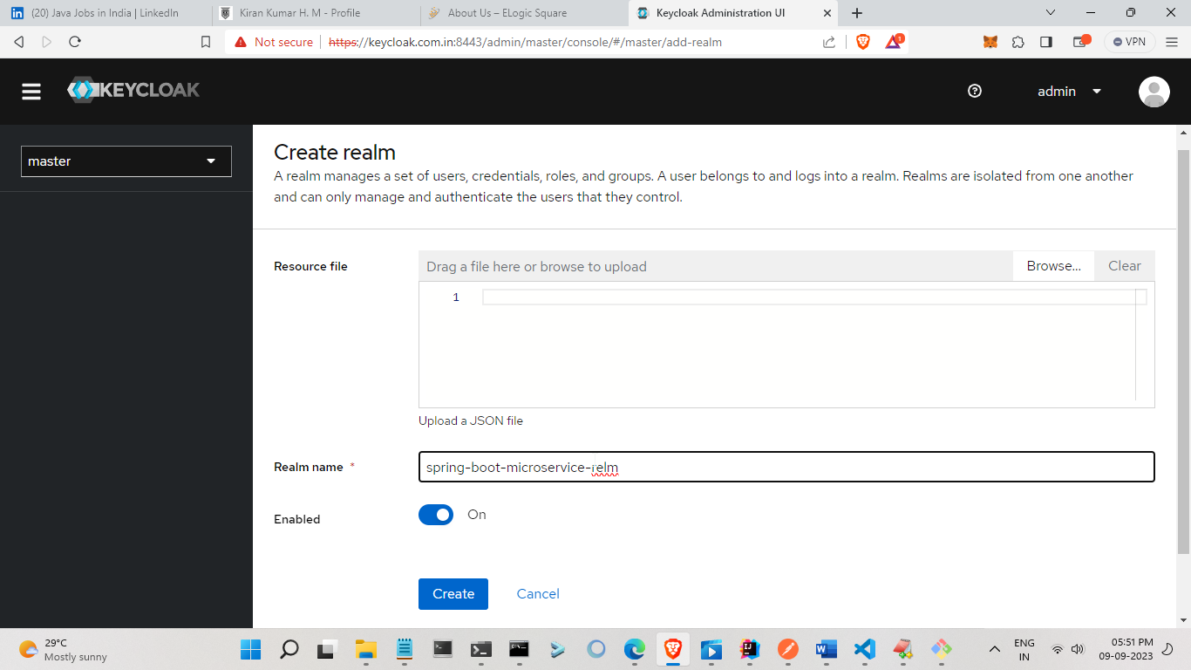

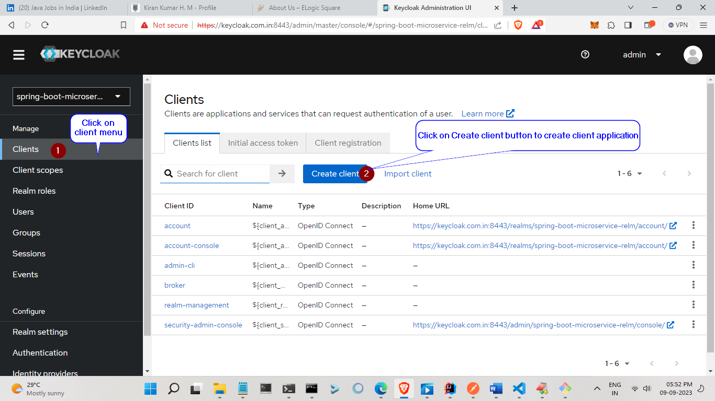

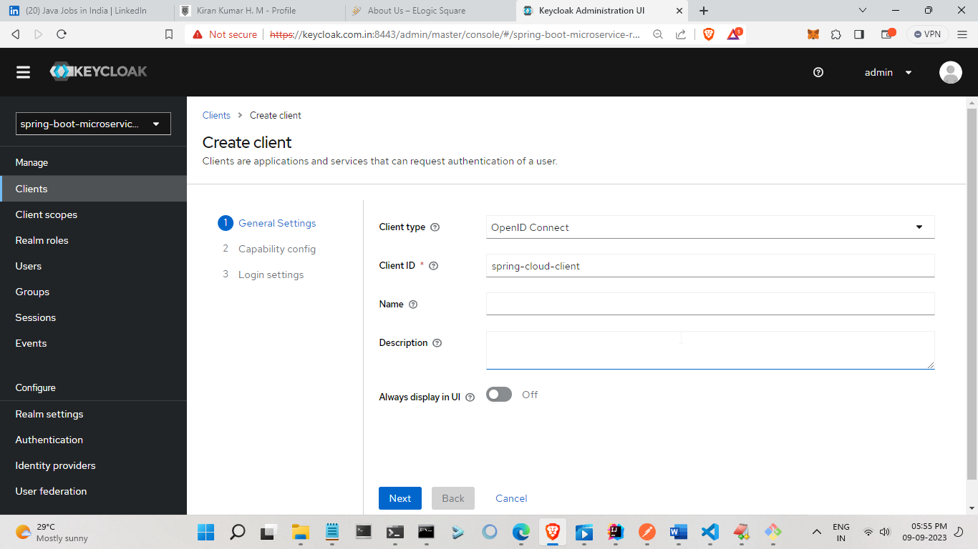

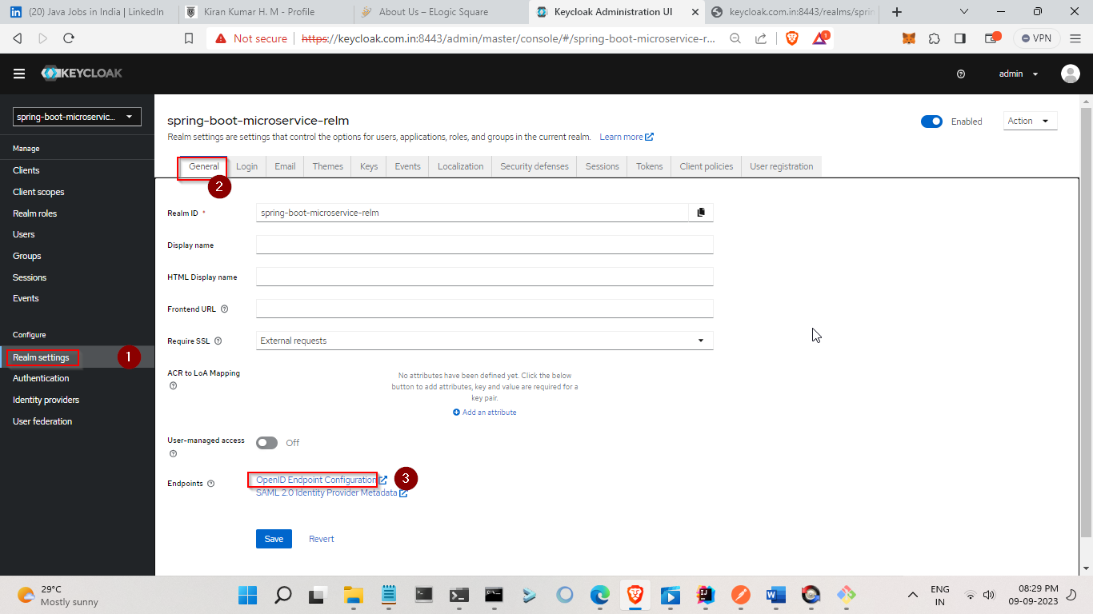



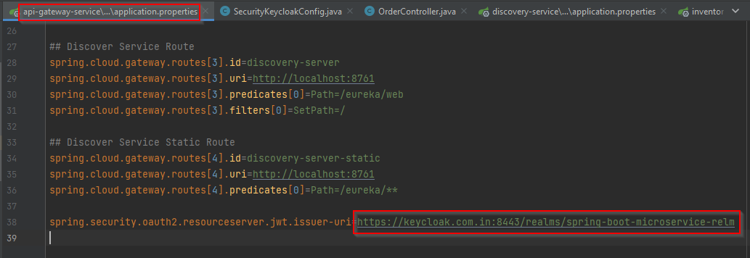

***Open cmd in Administrator and change directory where your certificate located***

***keytool -import -trustcacerts -file keycloak.com.in-key.crt -alias keycloak.com.in -keystore "C:\Program Files\Java\jdk-20\lib\security\cacerts" -storepass changeit***

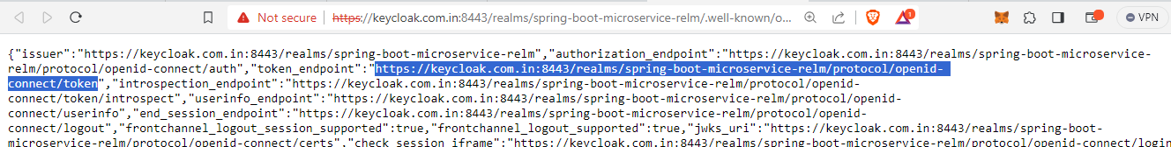

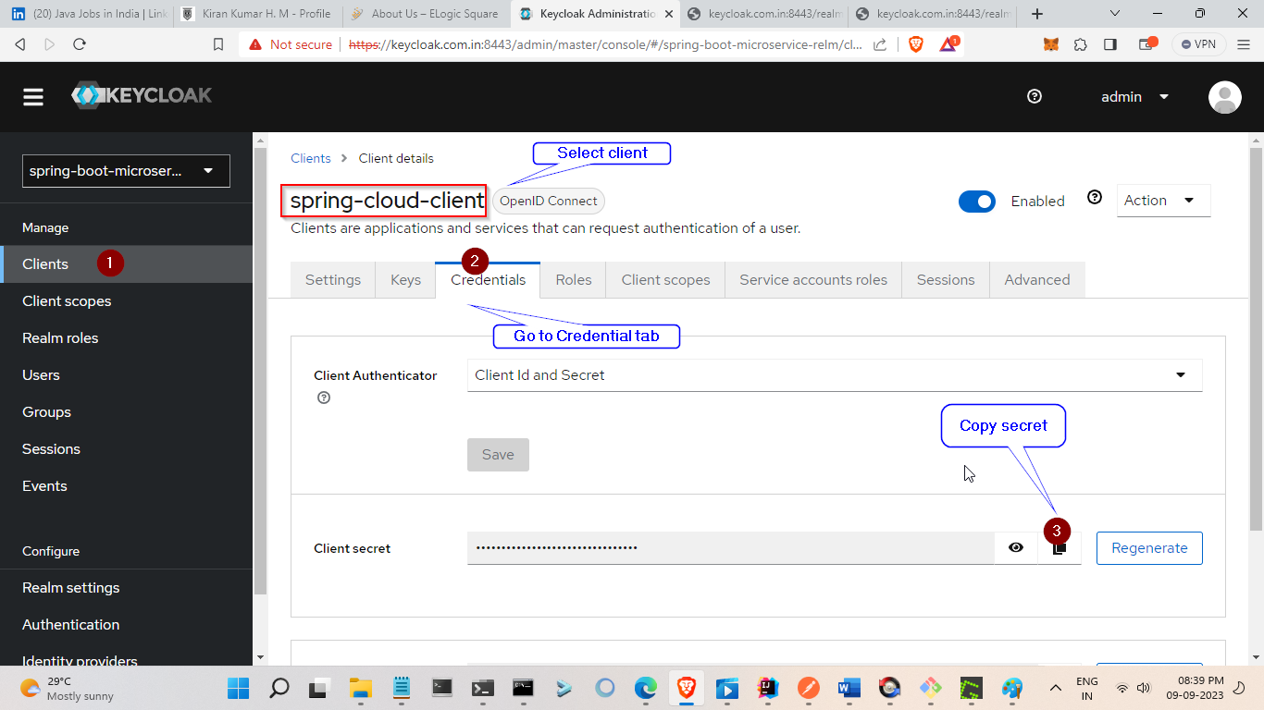

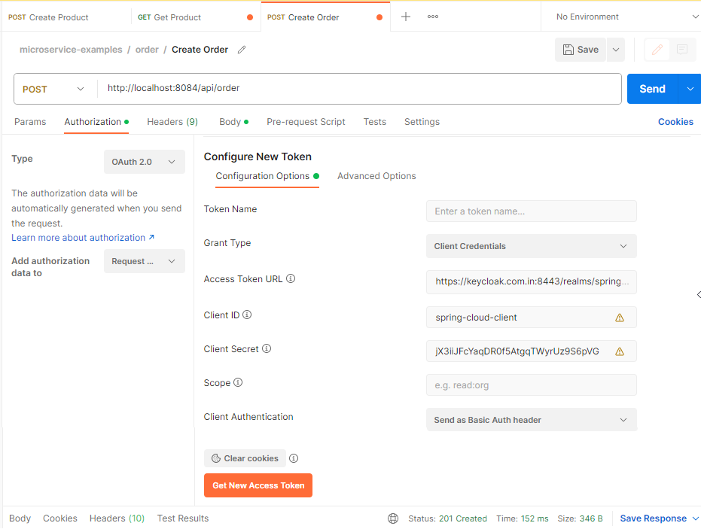

***Click on “Get New Access Token” and “Use Token” button***